**Assignment 4.3:**

Write a program to implement wordcount using Pig

Creating a sample ‘wordcountfile.txt’



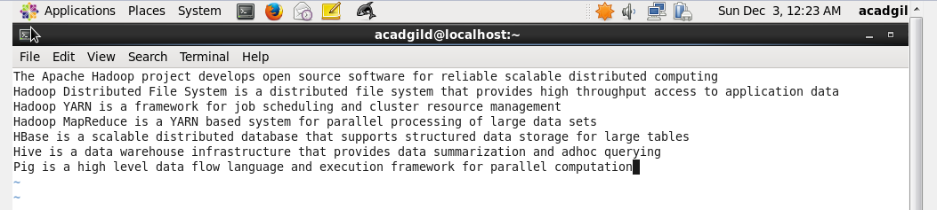

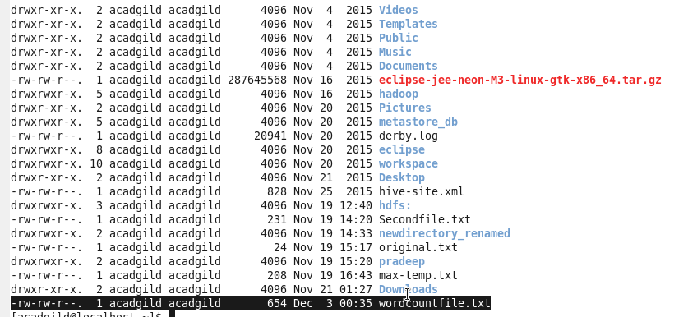

Copying ‘wordcountfile.txt’ from local to HDFS





Below are the steps for Pig scripts to count the occurrence of each word:

**Step1:** loading file in to variable ‘lines’:







**Step2:** Splitting each line in to words using the TOKENIZE operator

TOKENIZE function creates a bag of words

FLATTEN function converts bag into a tuple.





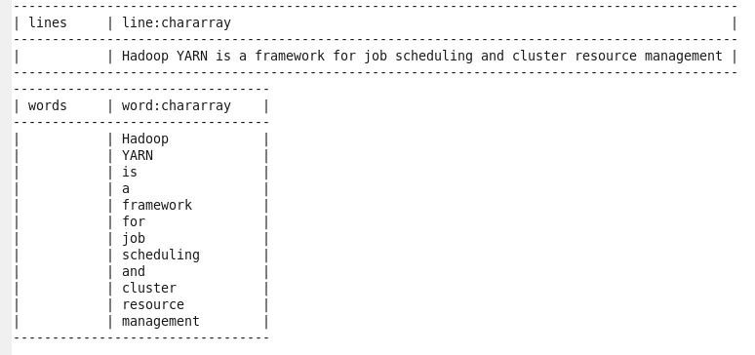

**Step3:** Grouping the words together





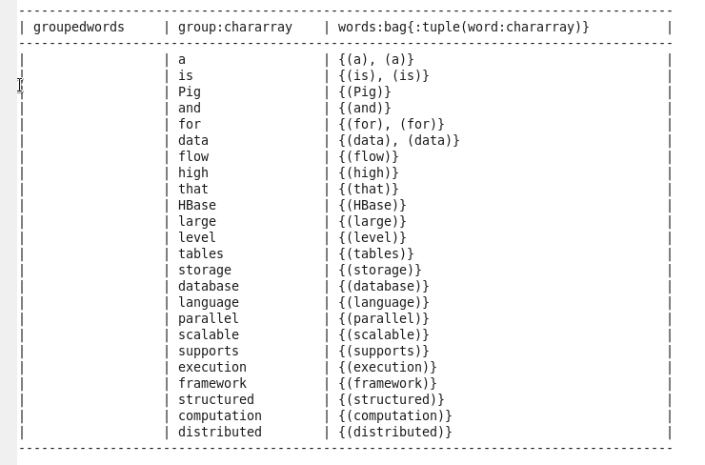

**Step4:** Computing count





**Output:** Below is the output of word count:

